AP ART HISTORY SUMMER ASSIGNMENTS
Welcome to AP Art History. If you take this course seriously, it can change the way you see the world. You will see elements of buildings, culture and media in ways you overlooked in the past. I'm glad you've accepted the challenge, and I promise to do everything I can to make the class entertaining as well as highly informative!
THE ASSIGNMENT:
1. PURCHASE MATERIALS AND READ: The Annotated Mona Lisa by Carol Strickland. Read the Introduction in The Annotated Mona Lisa, Carol Strickland: How To Look At Art (Mona Lisa).
2. Select ONE Artwork from each time period, totaling four pieces all together.
Time Periods:
- -Prehistoric Through Medieval, p. 2-29
- -Renaissance and Baroque, p. 30-65
- -The Twentieth Century: Modern Art, p. 128-167
- -The Twentieth Century and Beyond: Contemporary Art, 168-202
3. Create an artist’s portfolio to showcase the works of art and your analysis of each. You will need to purchase a sketch book, 8.5 x 11 or larger with blank sheets.
4. Print out pictures of the four pieces of art that you have chosen.
5. Tastefully glue/tape them to a spread (two open sheets of paper)
6. Write a paragraph about each piece of art in which you answer the following:
- What was the purpose of this piece of art?
- Why did you choose this piece? What do you find interesting about it?
3. Properly label all works selected (examples appear at the bottom of most works in Mona Lisa, but should include: Artist (when known), Title or Descriptive Name of Work, Date, Original Location
5. Material/Materials work is made of, Size (height before width) in feet and inches, and Present location.
If you have any questions please feel free to email me at Jessica.cameron@sccpss.com
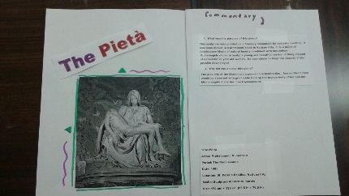 Example

